**Attributes (Master Data Services)**

**SQL Server 2014**

[Other Versions](javascript:;)

http://i.msdn.microsoft.com/Areas/Epx/Content/Images/ImageSprite.png

* [SQL Server 2012](http://msdn.microsoft.com/en-IN/library/ee633745(d=printer,v=sql.110).aspx)
* [SQL Server 2008 R2](http://msdn.microsoft.com/en-IN/library/ee633745(d=printer,v=sql.105).aspx)

Attributes are objects that are contained in Master Data Services entities. Attribute values describe the members of the entity. An attribute can be used to describe a leaf member, a consolidated member, or a collection.

[**How Attributes Relate to Other Model Objects**](javascript:void(0))

You can think of an attribute as a column in an entity table. An attribute value is the value used to describe a specific member.

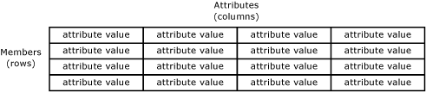

When you create an entity that contains many attributes, you can organize the attributes into attribute groups. For more information, see [Attribute Groups (Master Data Services)](http://msdn.microsoft.com/en-IN/library/ff486982.aspx).

[**Required Attributes**](javascript:void(0))

When you create an entity, the Name and Code attributes are automatically created. Code requires a value and must be unique within the entity. You cannot remove the Name and Code attributes.

[**Attribute Types**](javascript:void(0))

There are three types of attributes:

* Free-form attributes, which allow free-form input for text, numbers, dates, or links.
* Domain-based attributes, which are populated by entities. For more information, see [Domain-Based Attributes (Master Data Services)](http://msdn.microsoft.com/en-IN/library/ff487058.aspx).
* File attributes, which are used to store files, documents, or images. File attributes are intended to help with the consistency of your data by requiring files to have a specific extension. File attributes cannot be guaranteed to prevent a malicious user from uploading a file of a different type.

**Numeric Free-Form Attributes**

Numeric free-form attributes require special handling, because numeric free-form attribute values are limited to the SqlDouble value type.

By default, a SqlDouble value contains 15 decimal digits of precision, although a maximum of 17 digits is maintained internally. The precision of a floating-point number has several consequences:

* Two floating-point numbers that appear equal for a particular precision might not compare equal because their least significant digits are different.
* A mathematical or comparison operation that uses a floating-point number might not yield the same result if a decimal number is used because the floating-point number might not exactly approximate the decimal number.
* A value might not roundtrip if a floating-point number is involved. A value is said to roundtrip if an operation converts an original floating-point number to another form, an inverse operation transforms the converted form back to a floating-point number, and the final floating-point number is equal to the original floating-point number. The roundtrip might fail because one or more least significant digits are lost or changed in a conversion.

[**Attribute Examples**](javascript:void(0))

In the following example, the entity has the attributes: Name, Code, Subcategory, StandardCost, ListPrice, and FilePhoto. These attributes describe the members. Each member is represented by a single row of attribute values.

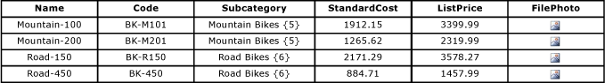

In the following example, the Product entity contains:

* The free-form attributes of Name, Code, StandardCost and ListPrice.
* The domain-based attribute of Subcategory.
* The file attribute of FilePhoto.

Subcategory is an entity that is used as a domain-based attribute of Product. Category is an entity that is used as a domain-based attribute of Subcategory. Like the Product entity, the Category and Subcategory entities each contain the default Name and Code attributes.

